

**Adaptable technological solutions based on early design actions for the construction and renovation of Energy Positive Homes**

**AGENDA**

**LEGOFIT 1st Project Meeting**

**Date of the meeting:**

**12 – 13 September 2023**

**Version 2 | 17.08.2023**



**Venue:** Gazhane Museum

**Location:** Kurbağalıdere Cd. No:125 Hasanpaşa/Kadıköy, İstanbul

[Google Maps](https://www.google.com/maps/place/Gazhane+Museum/@40.9933768,29.0384832,15z/data=!4m15!1m7!3m6!1s0x14cab80b23ed2915:0x4bdfeb36fc52e4c1!2sGazhane+Museum!8m2!3d40.9961818!4d29.0426306!16s%2Fg%2F11rrt_d4qr!3m6!1s0x14cab80b23ed2915:0x4bdfeb36fc52e4c1!8m2!3d40.9961818!4d29.0426306!15sCg1tw7x6ZSBnYXpoYW5lWg8iDW3DvHplIGdhemhhbmWSAQZtdXNldW2aASRDaGREU1VoTk1HOW5TMFZKUTBGblNVTjFPVXRsY0Y5M1JSQULgAQA!16s%2Fg%2F11rrt_d4qr?entry=ttu)

**Web site:** <https://muzegazhane.istanbul/>

**Contact info:** Beril Alpagut, [balpagut@demirenerji.com](mailto:balpagut@demirenerji.com), +90 533 237 62 00

Oya Tabanoğlu, [otabanoglu@demirenerji.com](mailto:otabanoglu@demirenerji.com), +90 506 496 64 70

Buse Araç, [baraç@demirenerji.com](mailto:baraç@demirenerji.com), +90 531 918 32 75

Dilan Cengiz, [dcengiz@demirenerji.com](mailto:dcengiz@demirenerji.com), +90 531 353 31 71

# Objective of the meeting

The LEGOFIT 1st Periodic Meeting is aimed at gathering all project partners and establishing a common understanding of the project background, objectives and expected results as well as coordinating and planning the first activities to be implemented in its first meeting.

The Periodic Meeting will be taking place on the 12-13 of September 2023 and will provide a real setting for creating a first connection among the cities and the technical partners of the project.

The official Periodic Meeting is structured in a 2 days meeting (with a set of sessions to cover the following topics):

* Review of the scope and objectives
* Establishment of the methodology and creating topics for LEGOFIT platform development
* Definition of roles and responsibilities and interconnections between WPs
* Review of legal and financial issues
* Establishment of the next steps

# Project Meeting Venue

##### Brief information about Istanbul:

Istanbul is a member of the Global Covenant of Mayors for Climate & Energy and selected as one of the 112 Mission Cities by the EC, to be supported by the NetZeroCities and reach climate neutrality by 2030.

|  |  |
| --- | --- |
|  |  |
|  |  |

##### Project Venue: Gazhane Museum

The Gazhane area (former gas distribution plant that supplied energy to the entire city), built in 1892 on the Asian side of the Bosporus, houses a museum, a venue for cultural events, and recreational opportunities for local people since it was transformed into a “public space” by the «adaptive reuse» of the gasworks in 2021. The area represents “Refurbishment of the Industrial Heritage” consisting of an Energy and Climate Museum, Workshop Spaces, Arts and Crafts Ateliers, a Recreational Center, Restaurants, Library, and Bookshops. The museum is already a site for the history of energy, making it the ideal location for the LEGOFIT venue.

|  |  |
| --- | --- |
|  |  |

# Practical Information

##### Money

The currency is Turkish Lira (₺). The current exchange is 1 € = 29,6 ₺. You can follow the currency exchange in this [link.](https://www.tcmb.gov.tr/wps/wcm/connect/en/tcmb+en/main+menu/statistics/exchange+rates/indicative+exchange+rates)

Most cards are accepted in ATMs to get cash. Exchanging money at the airports is also available.

##### Weather

Weather conditions is in Istanbul will be generally sunny, there is a small possiblty to see rainy day; and estimated between 22oC and 28oC during in September.

##### Tourist info:

Tourism Information Offices provide the information and documents about İstanbul like brochures, leaflets maps etc. for local and foreign tourists.

[*more details*](https://istanbul.ktb.gov.tr/EN-284752/tourism-information-offices.html)

##### How to reach Istanbul / Kadıköy

Since Istanbul is composed of two continents, there is an airport on each continent as Istanbul Airport (IST) and Sabiha Gökçen International Airport (SAW). In terms of proximity to the venue, our recommendation is to fly to İstanbul Sabiha Gökçen International Airport (SAW).

##### From Sabiha Gökçen International Airport (SAW) to Kadıköy:

Here are the correct transportation alternatives to travel from Sabiha Gökçen Airport to the center of Kadıköy:

**Taxi:** Taxis are available at Sabiha Gökçen Airport, and you can easily find them outside the arrivals area. A taxi ride from the airport to the center of Kadıköy typically takes around 30-45 minutes, depending on traffic conditions. *(Approximate cost 13-16£)*

*\*You can also download and use the BiTaksi or Uber app.”*

[*Android*](https://play.google.com/store/apps/details?id=com.bitaksi.musteri&hl=en&gl=US&pli=1)***,*** [*IOS*](https://apps.apple.com/us/app/bitaksi-your-taxi/id589500723)

**Airport Shuttle:** Sabiha Gökçen Airport offers shuttle services that connect the airport with various destinations in Istanbul, including Kadıköy. These shuttles operate on a scheduled basis and provide a convenient transportation option. You can inquire about the shuttle schedules, fares, and pick-up points at the airport or through the official airport website.

*\*You can find the shuttle information in this link:*

[*https://www.havabus.com/yolcuservisi/kadikoy-sabihagokcenhavalimani.aspx*](https://www.havabus.com/yolcuservisi/kadikoy-sabihagokcenhavalimani.aspx)

**Public Bus:** Several public bus lines serve the route between Sabiha Gökçen Airport and Kadıköy. Bus lines E10, E11, and E18 are commonly used to travel from the airport to Kadıköy. The travel time can vary depending on traffic conditions, but it generally takes around 30-60 minutes to reach the center of Kadıköy.

**Metro:** Another option is to utilize the metro and ferry services. From Sabiha Gökçen Airport, transfer to the M4 metro line and ride it to Kadıköy Station. From there, you can walk or take the taxi to your hotel. The total travel time can vary but typically takes around 60 minutes to 90 minutes, depending on connections and waiting times.

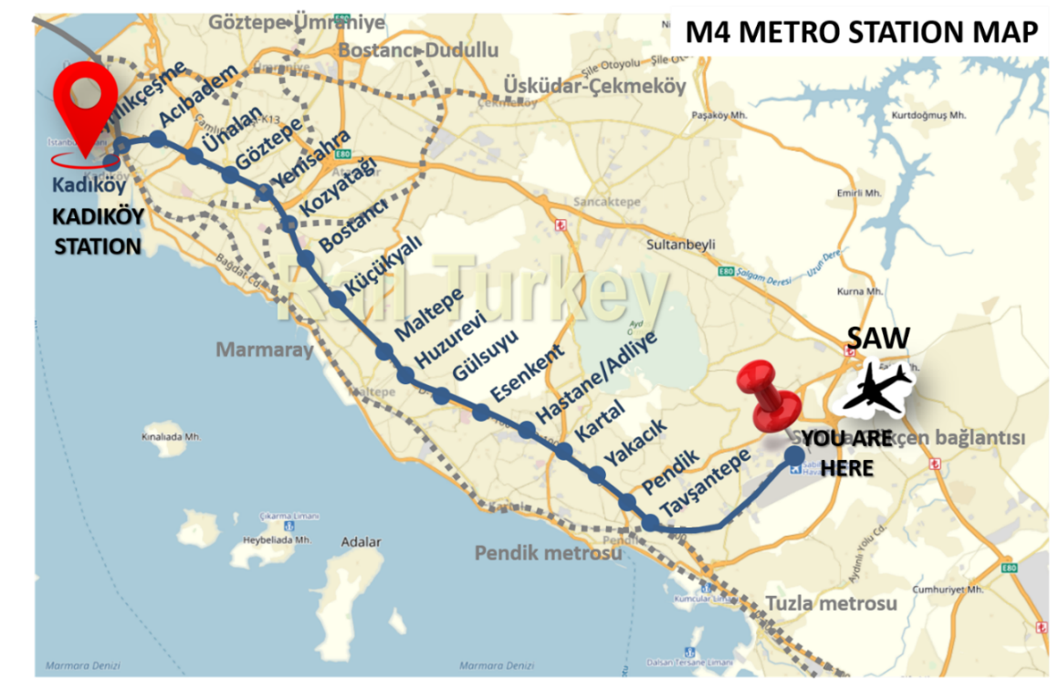

*\*Link:* [*https://www.metro.istanbul/en/Hatlarimiz/HatDetay?hat=M4*](https://www.metro.istanbul/en/Hatlarimiz/HatDetay?hat=M4)

##### From Istanbul Airport (IST) to Kadıköy

To travel from Istanbul Airport to Kadıköy, you have several transportation options. Here are the different alternatives:

**Taxi:** Taxis are readily available at Istanbul Airport. You can find taxi stands outside the arrivals area. It's important to use official taxis with meters and always ask for the estimated fare before starting your journey. The taxi ride to Kadıköy usually takes around 40-60 minutes, depending on the traffic conditions. *(Approximate cost 23-28€)*

*\* You can also download and use the BiTaksi and Uber app.*

**Airport Shuttle:** Istanbul Airport offers shuttle services to various destinations in the city, including Kadıköy. You can check with the airport authorities or shuttle service providers for schedules, fares, and pick-up points. These shuttles are comfortable and provide a convenient way to reach your destination.

*\*You can find the shuttle information in this link:*

[*https://www.hava.ist/tr/Voyage/VoyageTime*](https://www.hava.ist/tr/Voyage/VoyageTime)

**Public Bus:** Istanbul's public bus network is extensive and cost-effective. From Istanbul Airport, you can take the H-1 or H-2 bus lines, which operate 24/7 and connect the airport with Kadıköy. These buses have luggage compartments to store your bags. The journey duration may vary depending on traffic conditions, but it usually takes around 60-90 minutes.

**Metro:** Another option is to use a combination of the metro and ferry services. From Istanbul Airport, take the M11 metro line (Havalimanı-Kızılay) to Yenikapı Station. At Yenikapı, transfer to the Marmaray suburban train to reach Ayrılık Çeşmesi Station. From there, you can walk a short distance to the nearby Kadıköy. The total travel time can range from 90 minutes to 2 hours, depending on connections and waiting times.

**Note:** The availability, schedules, and fares of public transportation may change over time, so it's always a good idea to check for updates before your journey. Additionally, consider the traffic conditions and the time of day you'll be traveling, as they can significantly impact travel times.

##### Other useful information

*\*You will need a ticket to use the metro or ferry in Istanbul. Here are two options:*

**Istanbulkart:** Istanbulkart is the most common card used for public transportation in Istanbul. By purchasing and loading this card, you can use it for all your transportation needs, including the metro, tram, bus, and ferry. Istanbulkart can be obtained from specific locations or İETT offices. When you initially purchase it, you will receive an empty card that you can then load with credit. To load the Istanbulkart, you will need to prepay a certain amount. By using your Istanbulkart, you can make payments by tapping the card on the readers when boarding public transportation.

**Single-Use Tickets:** There are also single-use tickets available for public transportation in Istanbul. These tickets can be used only once. They can be purchased from ticket machines at metro and tram stations or from ticket booths at some bus stops. When using single-use tickets, you will need to make a payment each time you travel.

The choice between these options is up to you. If you use public transportation frequently and want a more cost-effective option, using the Istanbulkart would be advantageous. However, if you use public transportation infrequently or plan to travel only once, single-use tickets can be a suitable choice.

##### Where to Stay?

We have listed a few hotels near the venue where your kickoff will take place. Unfortunately, it is not possible to give a final Price since the prices skyrocketed after the election (don’t worry € Exchange rate is also increasing). We tried to choose the hotels within the price ranges of EU rules. There are a lot of other hotels you might find please check their ratings and try not to choose hotels closet o Kadikoy seaside (mostly cheaper but quality is not good as well)

Here are the hotel locations that we have found for you to see the proximity to the venue.

|  |  |  |
| --- | --- | --- |
| Area | Hotel | Website |
| Kadıkoy Bagdat Street | Suadiye Otel | <https://www.hotelsuadiye.com/> |
| A11 Hotel Kadıkoy | https://a11hotel.com/room/a11-hotel-cadde/ |
| Kadıköy | Holiday Inn | https://www.holidayinn.com |
| Ghan Hotel | https://www.ghanhotel.com/# |
| DoubleTree by Hilton Moda | https://www.hilton.com/en/hotels/istimdi-doubletree-istanbul-moda/ |
| Koşuyolu | Buem Otel | <https://buemhotel.com/> |

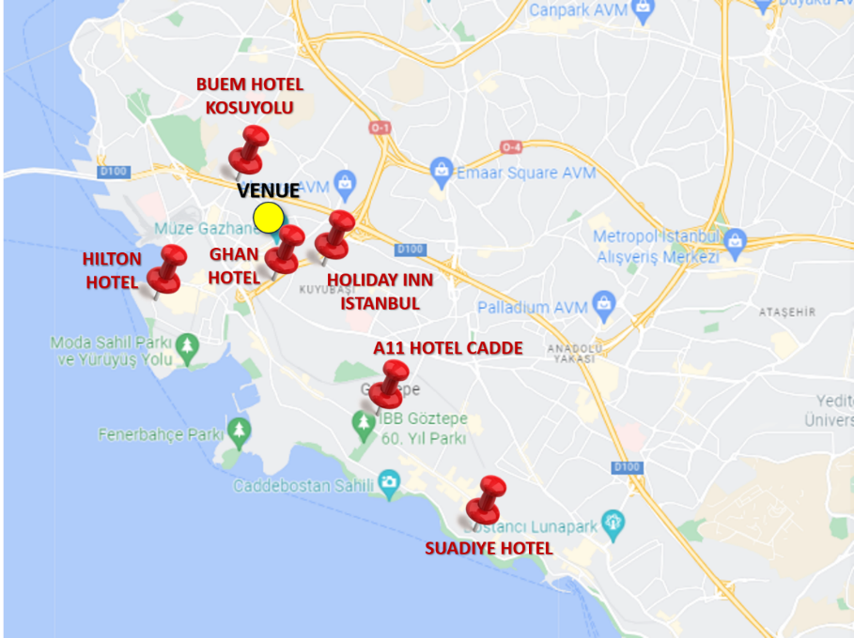

##### New Accomodation Suggestions:

* [La Vita Suites](https://tr.hotels.com/ho1503536224/la-vita-suites-istanbul-turkiye/?chkin=2023-08-11&chkout=2023-08-12&x_pwa=1&rfrr=HSR&pwa_ts=1690546527262&referrerUrl=aHR0cHM6Ly90ci5ob3RlbHMuY29tL0hvdGVsLVNlYXJjaA%3D%3D&useRewards=false&rm1=a2&regionId=1639&destination=%C4%B0stanbul%2C%20Istanbul%2C%20T%C3%BCrkiye&destType=MARKET&neighborhoodId=6241171&selected=46954257&latLong=41.01357%2C28.96352&sort=RECOMMENDED&top_dp=3009&top_cur=TRY&semdtl=a115302685330.b1130914709196.g1kwd-874985272042.e1c.m1CjwKCAjwzo2mBhAUEiwAf7wjklijUw0qAh2C9yXnZNlYWL4FuLX2CRb36F_ukDEMoHUN0hcMVKia4RoCWDYQAvD_BwE.r1e192595f121a30315c492d6151241cf6e1bdcdf234b7f7eca42d927375e1c140.c1CXaUJFglHtkOnbt_OWmZDg.j11012782.k11012782.d1569692903609.h1e.i1.l1.n1.o1.p1.q1.s1.t1.x1.f1.u1.v1.w1&semcid=HCOM-TR.UB.GOOGLE.PT-c-TR.HOTEL&gclid=CjwKCAjwzo2mBhAUEiwAf7wjklijUw0qAh2C9yXnZNlYWL4FuLX2CRb36F_ukDEMoHUN0hcMVKia4RoCWDYQAvD_BwE&userIntent=&selectedRoomType=231924629&selectedRatePlan=286328800&expediaPropertyId=46954257&searchId=133221a8-f233-47dd-8145-4975aa5078c7) ***

Osmanağa Mahallesi, Bekçi Sokak, No: 8, Kadıköy, İstanbul

* [**Sidonya Hotel**](https://tr.hotels.com/ho371490/sidonya-hotel-istanbul-turkiye/) **\*\*\***

Rasimpaşa Mahallesi, Rıhtım Cad. Nemlizade Sk. No: 34, Kadıköy, İstanbul

* [**Rıhtım Otel**](https://www.rihtimotel.com/en/) **\*\*\***

Rasimpaşa Mahallesi, Rıhtım Cd. No: 62, Kadıköy, İstanbul

* [**Deniz Hote**](http://www.denizotel.com.tr/eng/default.asp)**l \*\*\***

Rasimpaşa Mahallesi, Orgeneral Şahap Gürler Cd. No: 2, Kadıköy, İstanbul

* [**İkiz Konak Boutique Hotel**](https://tr.hotels.com/ho2468454752/ikiz-konak-boutique-hotel-istanbul-turkiye/)***

Rasimpaşa Mahallesi, Recaizade Sok. No: 32/1, Kadıköy, İstanbul

* [**Istanbul Life Hotel**](https://tr.hotels.com/ho629317/istanbul-life-hotel-adults-only-istanbul-turkiye/) **\*\*\*\***

Rasimpaşa Mahallesi, Rıhtım Cad. Reşit Efendi Sk No: 11, Kadıköy, İstanbul

* [**Best Hotel Kadikoy**](https://tr.hotels.com/ho2428649024/best-hotel-kadikoy-istanbul-turkiye/) **\*\*\*\***

Rasimpaşa Mahallesi, Nüzhet Efendi Sokak No: 34, Kadıköy, İstanbul

* [**Kadıköy Park Suites**](https://tr.hotels.com/ho753087200/kad-koy-park-suites-istanbul-turkiye/) **\*\*\*\*\***

Hasanpaşa Mahallesi, Dr. Fahrettin Gökay Caddesi No: 55, Kadıköy, İstanbul

# Meeting agenda

##### Overall agenda of LEGOFIT Periodic Meeting 1, Istanbul

|  |  |  |
| --- | --- | --- |
| **Time** | **Tuesday 12th of September** | **Wednesday 13th of September** |
| **08h30 – 09h00** | Registration and welcome coffee | Registration and welcome coffee |
| **09h00 – 09h30** | DEMIR ENERJI WELCOME | **TOPIC 3:** Digital Building Logbook **(LIST)** |
| **09h30 – 10h00** | Ice-breaking Session and Begin Creating Connections | **TOPIC 5:** MCDM Algorithm **(METU)** |
| **10h00 – 10h30** | Meeting objectives, agenda, Project overview **(DEM)** | **TOPIC 4:** Control and Optimization **(AUG)** |
| **10h30 – 11h00** | Project Officer Presentation (Remote) **(EC)** | **TOPIC 7:** LEGOFIT Platform Use in Pilots **(ABUD)** |
| **11h00 – 11h30** | **Coffee break** | **Coffee break** |
| **11h30 – 12h00** | **TOPIC 1:** PED Framework & Evaluation – KPIs Definition **(CER)** | **WS 2: LEGOFIT Decision-Making Platform: 5 pilots & Energy Positive Homes (LIST + METU + CER)** |
| **12h00 – 12h30** | **TOPIC 2:** BIM Models & Digital Twins **(IES + R2I)** |

|  |  |  |
| --- | --- | --- |
| **12h30 – 13h30** | **Lunch Break** | **Lunch Break** |

|  |  |  |
| --- | --- | --- |
| **13h30 – 14h00** | Travel to OZU Demo-site | **TOPIC 6:** Economic and Social Models (E2C) |
| **14h00 – 14h30** | **WS3: KPIs & Evaluation of LEGOFIT Platform in pilots (ABUD)** |
| **14h30 - 15h00** | **Demo-Site Visit**: Ozyegin University Campus |
| **15h00 - 15h30** | **TOPIC 8:** LEGOFIT C&D – Training - Networking **(R2M)** |
| **15h30 - 16h00** | **WP7:** Coordination – Legal & Administrative Aspects **(DEM)** |
| **16h00 - 16h30** | Conclusions and commitments **(DEM)** |
| **16h30 – 17h30** | **WS 1:** Behaviour Change Program and tools **(OZU)** |  |

|  |  |  |
| --- | --- | --- |
| **19h00** | **Project dinner and boat trip on Bosphorus** |  |

##### Detailed Agenda

##### Day 1: 12th of September

|  |  |
| --- | --- |
| Time | Tuesday 12th of September |
| 08h30 – 09h00 | **Registration and welcome coffee** |
| 09h00 – 09h30 | Welcome from DEMIR Enerji |
| 09h30 – 10h00 | Ice-breaking Session and Begin Creating Connections   * A small game for strengthening interactions between LEGOFIT partners |
| 10h00 – 10h30 | Meeting objectives, agenda, Project overview **(DEM)**   * **Concept: LEGOFIT decision-making platform consisting of 8 TOPICs** * **Methodology: LEGOFIT Platform Use in pilots** |
| 10h30 – 11h00 | Project Officer Presentation (Remote) **(EC)** |

|  |  |
| --- | --- |
| 11h00 – 11h30 | Coffee break |

|  |  |
| --- | --- |
| 11h30 – 12h00 | TOPIC 1: PED Framework & Evaluation – KPIs Definition (CER)  WP1 LEGOFIT framework, drivers, assumption and potentials + WP5 Implementation, monitoring and validation in the pilot sites   * Task 1.1 Positive building existing framework in the LEGOFIT pilot countries * Task 1.2 Potential barriers and drivers for the development of an integrated design process in the construction sector * Task 1.3 LEGOFIT design process and platform requirements * Task 1.4 LEGOFIT KPIs definition * Task 1.5 Creation of LEGOFIT stakeholders’ community * Task 5.6 Design guidelines for energy positive buildings and suggestions for certification measures and sustainability protocols |
| 12h00 – 12h30 | **TOPIC 2:** BIM Models & Digital Twins **(IES + R2I)**  **WP2** Building and technologies modelling and digital twinning + **WP5** Implementation, monitoring and validation in the pilot sites   * Task 2.1 Characterization of pilot residential buildings and their surroundings * Task 2.2 Development of the BIM models of the pilot buildings and improved BIM models coordination * Task 2.3 Digital twinning of the pilot building * Task 5.5 Urban scale digital twins and LEGOFIT wider impacts |

|  |  |
| --- | --- |
| 12h30 – 13h30 | Lunch Break |

|  |  |
| --- | --- |
| 13h30 – 14h30 | Travel to OZU Demo-site (All partners will be transferred by bus) |
| 14h30 - 16h30 | **Demo-Site Visit**: Ozyegin University Campus |
| 16h30 – 17h30 | **WS 1: Behaviour Change Program and tools (OZU)**   * 5 pilots – Discussions on Behaviour Program |
| 19h00 | **Project dinner and boat trip on Bosphorus**   * Boat trip details will be shared later |

##### Day 2: 13th of September

|  |  |
| --- | --- |
| Time | Wednesday 13th of September |
| 08h30 – 09h00 | **Registration and welcome coffee** |
| 09h00 – 09h30 | **TOPIC 3**: Digital Building Logbook **(LIST)**  **WP3** BIM-based open solutions for energy positive houses   * Task 3.1 Occupants needs and non-intrusive occupancy evaluation (POESY) * Task 3.4 Circularity in the construction sector - DDC platform * Task 3.6 LEGOFIT digital building logbook and circularity passport |
| 09h30 – 10h00 | **TOPIC 5:** MCDM Algorithm **(METU)**  **WP2** Building and technologies modelling and digital twinning   * Task 2.4 Definition and technical modelling of passive and active solutions * Task 2.5 Environmental and financial assessment of active and passive technologies * Task 2.6 Development of multicriteria decision-making algorithms for the selection of best building interventions |
| 10h00 – 10h30 | **TOPIC 4:** Control and Optimization **(AUG)**  **WP4** LEGOFIT smart management technologies and improved building performance   * Task 4.1 Multi-purpose forecasting for improved and predictive control and automatization * Task 4.2 Smart management technologies integration - Building Management System * Task 4.3 - System-level optimal strategy to deploy and manage LEGOFIT services * Task 4.4 Communication protocols and data model for the integration of services in the LEGOFIT platform |
| 10h30 – 11h00 | **TOPIC 7**: LEGOFIT Platform Use in Pilots **(ABUD)**  **WP5** Implementation, monitoring and validation in the pilot sites   * Task 5.1 LEGOFIT design process implementation and improvement over time * Task 5.2 LEGOFIT platform use in demonstration sites and support on measuring (as-built) building performance * Task 5.4 Evaluation of LEGOFIT design process |

|  |  |
| --- | --- |
| 11h00 – 11h30 | Coffee break |

|  |  |
| --- | --- |
| 11h30 – 12h00 | WS 2: LEGOFIT Decision-Making Platform: 5 pilots & Energy Positive Homes (LIST + METU + CER)   * All pilots identify their PED Boundaries * Technology Selections in PED Boundaries * Re(design) of PED by the help of LEGOFIT Platform (approach) |
| 12h00 – 12h30 |

|  |  |
| --- | --- |
| 12h30 – 13h30 | Lunch break |

|  |  |
| --- | --- |
| 13h30 – 14h00 | TOPIC 6: Economic and Social Models (E2C)  WP1 LEGOFIT framework, drivers, assumption and potentials + WP3 BIM-based open solutions for energy positive houses + WP5 Implementation, monitoring and validation in the pilot sites   * Task 1.5 Creation of LEGOFIT stakeholders’ community * Task 3.2 Marketplace development and LEGOFIT platform interface * Task 3.3 Performance-based crowdfunding campaigns and co-finance opportunities * Task 3.5 LEGOFIT Open Innovation community tool * Task 5.3 Co-financing and cost-benefit analysis in the pilot sites |
| 14h30 – 15h00 | **WS3: KPIs & Evaluation of LEGOFIT Platform in pilots (ABUD)**   * How will we measure LEGOFIT impact? * What are the potential KPIs? |
| 15h00 – 15h30 | **TOPIC 8**: LEGOFIT C&D – Training - Networking **(R2M)**  **WP6 –** Communication, Dissemination and Exploitation   * Task 6.1 Communication campaigns and Dissemination plan * Task 6.2 Exploitation activities and Intellectual Property Rights * Task 6.3 LEGOFIT process and platform business plan for enhanced scalability and replication * Task 6.4 Involvement of professionals and training activities for the use of LEGOFIT platform * Task 6.5 Clustering and synergies with related projects |
| 15h30 – 16h00 | **WP7:** Coordination – Legal & Administrative Aspects **(DEM)** |
| 16h00 – 16h30 | Conclusions and commitments **(DEM)** |

# Project dinner

Info will be shared later

# Attendance list

Info will be shared later